Water Jug problem
Name: Hemalakshmi H(192571049)
Aim:
To develop a Python program that solves the Water Jug Problem using a logical step-by-step approach without search algorithms, demonstrating how to measure exactly 2 litres using a 4-litre and a 3-litre jug.

Algorithm:
Step 1: Start with both jugs empty.
Step 2: Fill the 4-litre jug completely.
Step 3: Pour water from the 4-litre jug into the 3-litre jug until the 3-litre jug is full.
Step 4: Empty the 3-litre jug.
Step 5: Pour the remaining water from the 4-litre jug into the 3-litre jug.
Step 6: Fill the 4-litre jug again.
Step 7: Pour water from the 4-litre jug into the 3-litre jug until it is full.
Step 8: The 4-litre jug now contains exactly 2 litres.
Step 9: Display all steps and the final result.

Source Code:
def water_jug():
jug4 = 0
jug3 = 0

steps = []

# Step 1: Fill 4L jug
jug4 = 4
steps.append((jug4, jug3))

# Step 2: Pour 4 -> 3
pour = min(jug4, 3 - jug3)
jug4 -= pour
jug3 += pour
steps.append((jug4, jug3))

# Step 3: Empty 3L jug
jug3 = 0
steps.append((jug4, jug3))

# Step 4: Pour remaining 4 -> 3
pour = min(jug4, 3 - jug3)
jug4 -= pour
jug3 += pour
steps.append((jug4, jug3))

# Step 5: Fill 4L jug again
jug4 = 4
steps.append((jug4, jug3))

# Step 6: Pour 4 -> 3 until full
pour = min(jug4, 3 - jug3)
jug4 -= pour
jug3 += pour
steps.append((jug4, jug3))

print("Steps to reach 2 litres:")
for s in steps:
print(s)

print("\nGoal reached:", (jug4, jug3))

water_jug()
Flowchart:
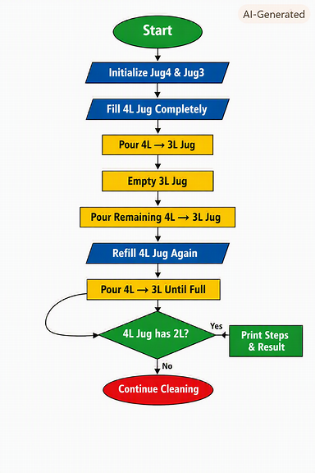

Output:
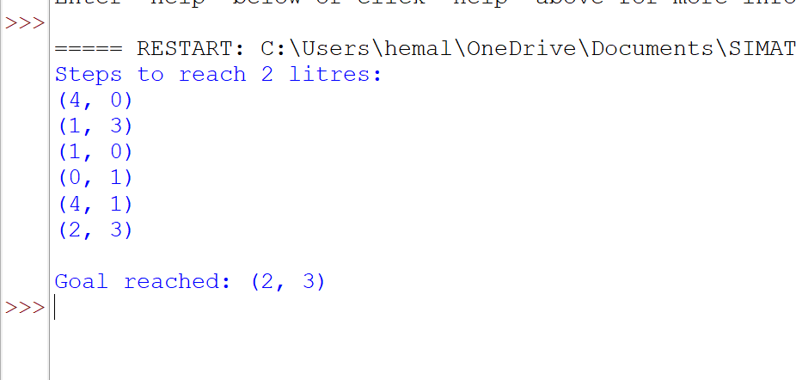
Result:
The Water Jug program successfully measured 2 litres using a 4-litre and a 3-litre jug without applying any search algorithm. The program followed a logical sequence of filling, pouring, and emptying operations.
At the end of execution, the 4-litre jug contained exactly 2 litres, confirming that the problem was solved correctly. Each step was displayed clearly, showing the transitions between jug states.
Thus, the Water Jug Problem was solved successfully using a logical step-by-step approach in Python.

